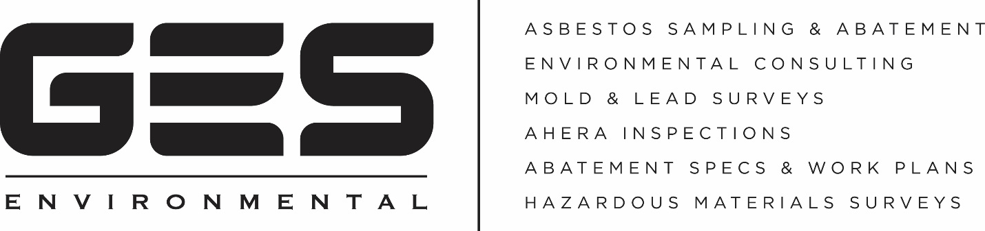

Why Property Management Professionals choose GES Environmental

Your unit owners & tenants are counting on you to keep them in business and restore their space quickly and accurately and GES Environmental can help.

Companies performing demolition or renovation in Massachusetts MUST test for the presence of Asbestos Containing Building Materials, (ACBM) regardless of the age of the building.

Some contractors still do not observe the MA Regulations leaving you and your building occupants at risk. GES Environmental was created to help property and facility management professionals streamline the restoration process by providing quick and accurate results and findings on sampling.
- Are you waiting days for test results?

GES Environmental will typically deliver your test results in less than 24 hours and in many cases, you’ll have them the same day.
- Does the company you use ask the lab to point count samples for greatest accuracy?

Point counting provides the most sophisticated analysis of samples and in many cases is able to rule out the need for time consuming and expensive abatement protocols.
Choose GES Environmental, A Company You Can Trust

888-830-6557 For More Information contact info@GESenviro.com

