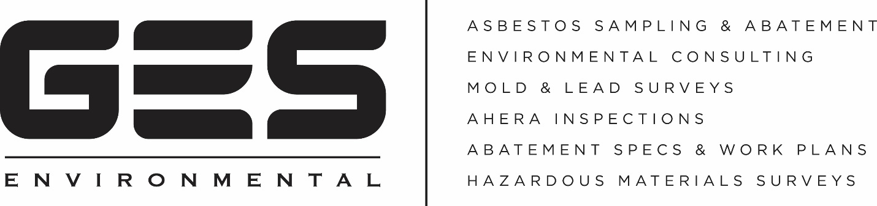

Attention Disaster Restoration Professionals If you provide water, fire & mold damage restoration you need to know the regulations.

Companies performing demolition or renovation in Massachusetts MUST test for the presence of Asbestos Containing Building Materials, (ACBM), regardless of the age of the building.

GES Environmental can help.

GES Environmental was created to help disaster restoration professionals streamline the mitigation and claim process by providing quick and accurate results and findings on sampling.
- Are you waiting days for test results?

GES Environmental will typically deliver your test results in less than 24 hours and in many cases you’ll have them the same day.
- Do you do Program Work and is Cycle Time Important to you?

Quick turn around time on test results will help you meet your metrics, reduce severities and provide exceptional service to the insured and your insurance customers.
- Does the company you use ask the lab to point count samples for greatest accuracy?

Point counting provides the most sophisticated analysis of samples and in many cases is able to rule out the need for time consuming and expensive abatement protocols.

Choose GES Environmental, A Company You Can Trust

888-830-6557

For More Information contact info@GESenviro.com

