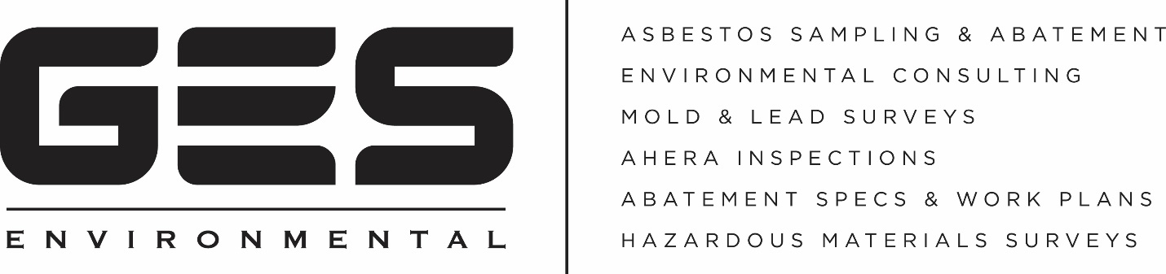

Why Home Owners choose GES Environmental

Home owners taking on a renovation or restoration project after suffering a property loss rely on their contractors to understand and adhere to state and federal regulations.

Companies performing demolition or renovation in Massachusetts MUST test for the presence of Asbestos Containing Building Materials, (ACBM) regardless of the age of the building.

Many contractors still do not observe the regulations leaving home owners at risk. GES Environmental was created to help home owners streamline the restoration process by providing quick and accurate results and findings on sampling.
- Are you waiting days for test results?

GES Environmental will typically deliver your test results in less than 24 hours and in many cases, you’ll have them the same day.
- Does the company you use ask the lab to point count samples for greatest accuracy?

Point counting provides the most sophisticated analysis of samples and in many cases is able to rule out the need for time consuming and expensive abatement protocols.
Choose GES Environmental, A Company You Can Trust

888-830-6557 For More Information contact info@GESenviro.com

